Example 1. Sergei Rachmaninoff. Prelude in G Minor, op, 23, no. 5. Mm. 1–16. Rectangles denote the two deviant measures of 2/4. Brackets show thematic material.

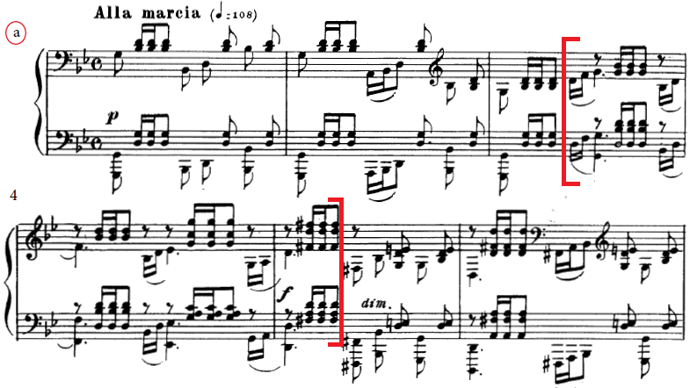
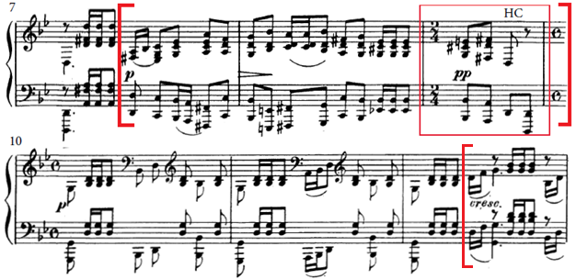
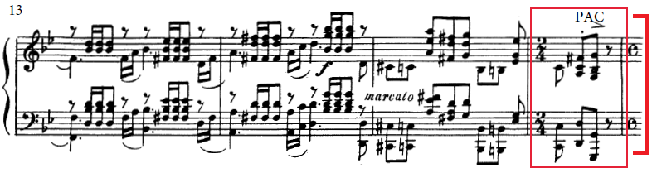

Example 2. Prelude in G Minor, formal diagram. Measure numbers correspond to Rachmaninoff’s notated measure.

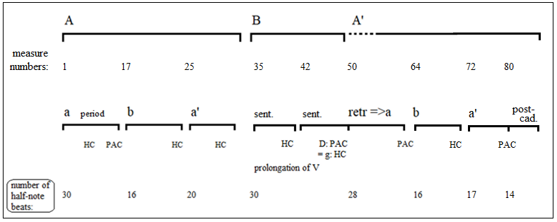
Example 3a. Section “a,” renotated in 2/4. Formal and metrical analysis. Circled numbers refer to the half note beats (1 = strong, 2 = weak). Measure numbers to refers to Rachmaninoff’s notated measures.
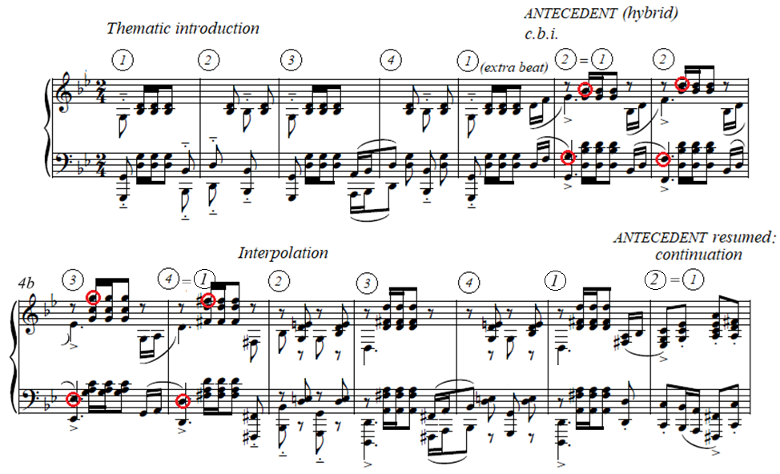
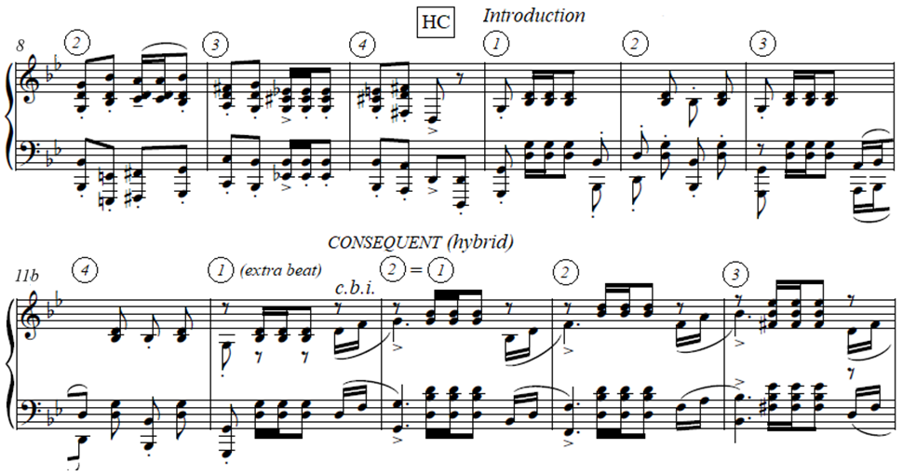

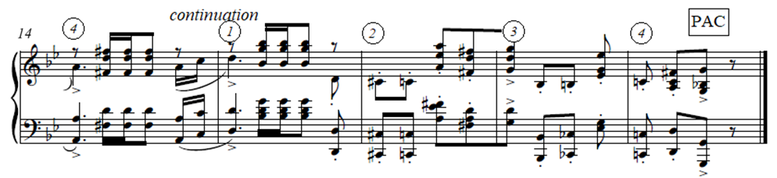

Example 3b. Section “a,” formal diagram.
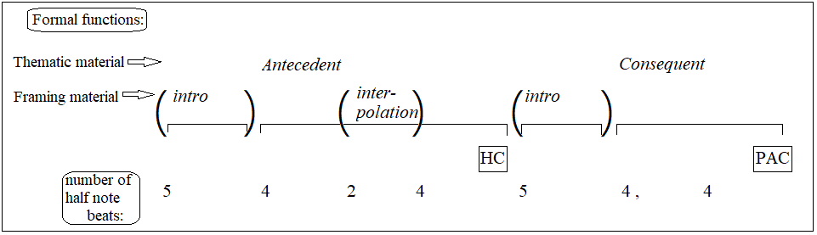

Example 4. Mm. 1–4 re-barred to place the deviant 2/4 in m. 3. Circled numbers refer to the half note beats (1 = strong).
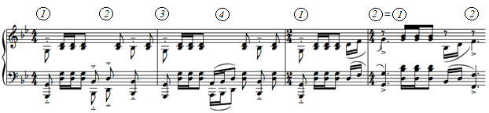

Example 5. Retransition=>a, mm. 50–56.
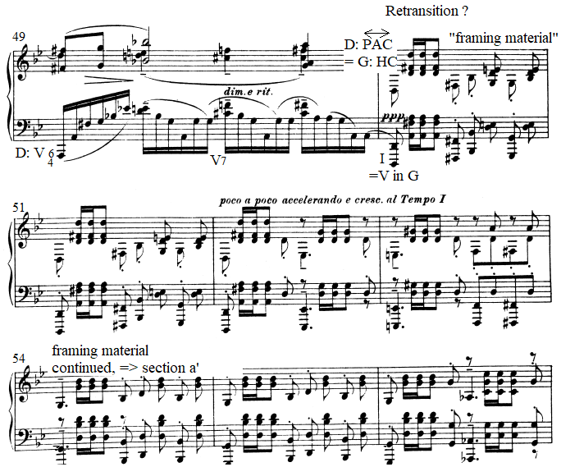

Example 6. Comparison of the two PACs: m. 16 and m. 63.
